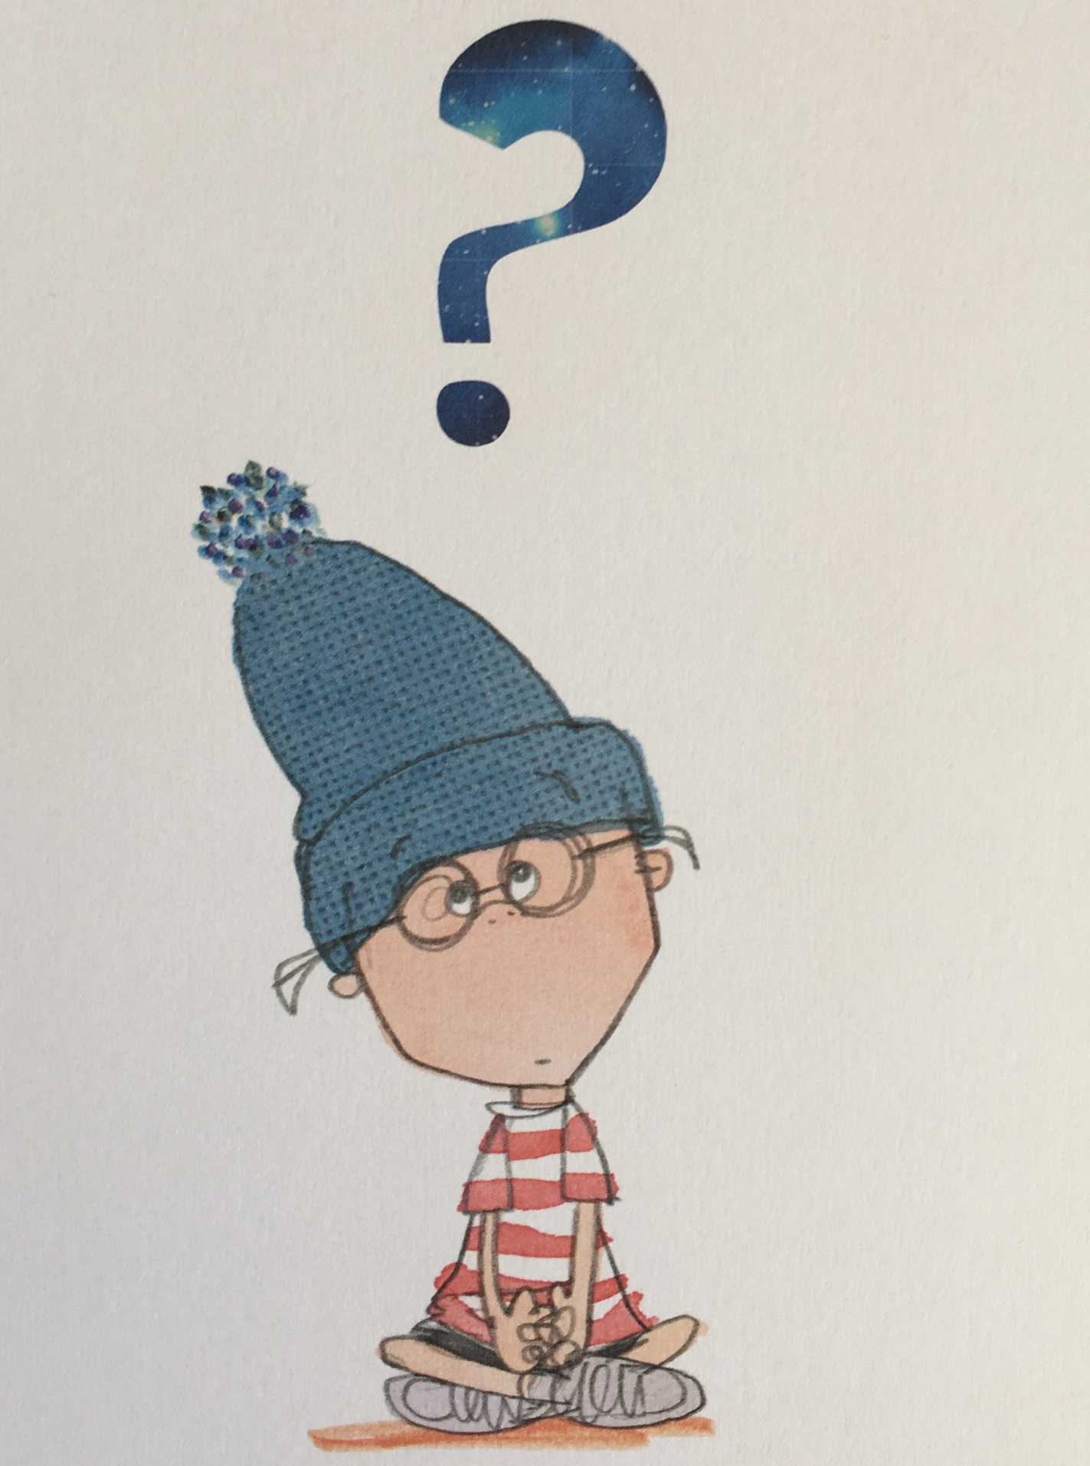

**Communication and language**

**Talking about family and people who are important**

**to us.**

**Listening to and joining in with stories and nursery rhymes.**

**Responding to others in conversation.**

**Answering**

**simple questions about books we have been**

**reading.**

**Joining in with role play and dressing up.**

**Personal, social and emotional development**

**Making new friends.**

**Playing turn-taking games.**

**Exploring the classroom and our school.**

**Deciding on and agreeing our class golden rules.**

**Learning routines of the school day.**

**Getting dressed independently for PE.**

**Learning about ourselves, our likes and dislikes.**

**These are some examples of the areas we will be covering through small group work,observation and play, allowing children to follow and develop their own interests.**

**Mathematics**

**Daily counting during class routines (snack**

**time, lining up).**

**Recognising numbers on a dice.**

**Recognising numbers.**

**Matching one to one accurately when**

**counting.**

**Matching numerals to quantities of**

**objects.**

**Introducing each number and its quantity.**

**Comparing heights of children.**

**Using positional language (between, behind**

**etc).**

**Physical development**

**Practising basic movements: running,**

**jumping, throwing and catching.**

**Developing balance agility and**

**coordination.**

**Understanding healthy food choices.**

**Developing fine and gross motor skills**

**for writing.**

**Learning to use scissors correctly.**

**Foundation Stage Autumn Term**

**2019 -2020**

***What Makes me a Me?***

**Understanding the world**

**Autumn and seasonal changes.**

**Identifying leaves.**

**Nature walk to explore our local area/school.**

**Investigating natural objects using**

**magnifiers, mirrors.**

**Exploring the senses and different parts of**

**our bodies.**

**Learning about Harvest festival.**

**Exploring the Ipads.**

.

***FS will have PE on a Friday. Please ensure that children have a full indoor PE kit in school all week. Long hair should be tied back and earrings removed as outlined in the school’s uniform policy on our website.***

**Literacy**

**Sharing books.**

**Reading books in class (eg.All about me, Family and Starting School books)**

**Talking about characters in books and our**

**favourite books.**

**Re-telling a story.**

**Learning to write our names and recognising each other’s names.**

**Beginning to hear and recognise letter sounds.**

**Mark making with a range of pens, paint and other media inside and outside.**

.

**Expressive arts and design**

**Exploring media and materials**

**Exploring musical instruments (loud and quiet**

**sounds).**

**‘Guess the instrument’ listening game.**

**Autumn leaf rubbings and printing.**

**Exploring colour and pattern**

**Making foil mirrors**

**Reading/Homework/Parent Workshops.More details to follow on Class dojo.**